TRAVEL AGENCY
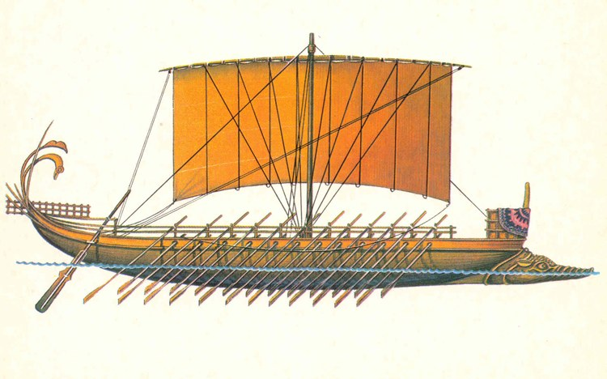
KALIPSO UKRAINE
TRAVEL AGENCY “KALIPSO UKRAINE”
Legal Address: Yakub Kolas street, 23, office 24, Kiev, Ukraine 03148
Actual Address: Mezhyhirska street, 39/20, office 28-29, Kiev, Ukraine, 04071
Phone: 495-57-93, fax: 425-05-05
e-mail:kalipso-ua@i.ua
www.kalipsoua.com

Grand tour around the CASTLES and MIRACLES of Ukraine
Kiev (2 nights) + Kamenetz - Podolsky (2 nights) - Chernivtsi (1 night) - Yaremche (1 night) - Mukacheve (3 nights) - Lviv (1 night) - Kiev
Guide services in English throughout the route!
Duration 12 days 11 nights
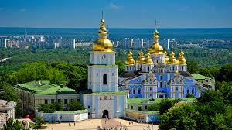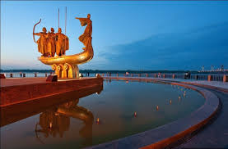
Route: Kiev - Kamenets-Podolsky - Zhvanets - Khotyn - Chernivtsi - Kitaygorod - Bakota - Kolomyia - Yaremche - Mukachevo - Kosino - Berehove - Lumshory - Uzhhorod - Chynadiyevo - Lviv - Kiev
Transport service throughout the tour!
Tour program:
Day 1
8:30 Arrival in Kiev, Meet-and-greet at the airport, after that you will obtain a visa to Ukraine.
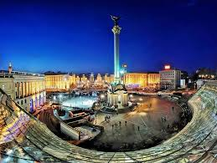
Then transfer to your hotel will be provided , followed by a breakfast and settling in. Also you will have some spare time before your city-tour around Kiev will begin. We will start from Taras Shevchenko Boulevard, Bessarabskaya Square, Khreshchatyk street, Independence Square, Valery Lobanovsky Dynamo Stadium, Verkhovna Rada (Supreme Council) of Ukraine, Mariinsky Park and Palace, Square Of Glory, Kievo- Pecherska Lavra, Mikhailovskaya Square and St. Michael's Golden-Domed Monastery, St. Sophia of Kiev, Golden Gate and other attractions of Kiev. Then we will proceed to Andreevsky descent (also known as Kiev’s Monmartr” and one of “must see” places in Kiev - Andreevskaya church. In the buildings, along the streets of "Kiev’s Montmartre", there are art galleries, exhibitions, theaters and art workshops. Numerous open air Ukrainian souvenir shops can also be found there.
Lunch in the Ukrainian folk style cafe. Departure for the excursion at the Museum of Ukrainian Architecture and Lifestyle "Pirogovo".
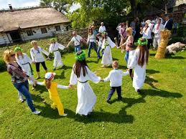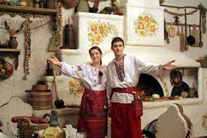
"All of Ukraine in one day" – that is how you can characterize the visit to this museum in the open air. Here, among the picturesque landscape, you will be lucky to find out what distinguishes the Carpathians from Polissya, Podillya from Transcarpathia, etc. Ukrainian huts, mills, churches, household items, handcrafted souvenirs - all this will open up for you the soul of Ukrainian people. You will have an opportunity to look at the spinning potter's wheel, to visit "shinok" (Ukrainian pub) or "kulishna" (Ukrainian soup place), to go for the horse ride around countryside for some fresh Ukrainian air and great photos to remember!
Return to Kiev.
Delicious dinner at a cafe. Return to hotel. Overnight.
Day 2
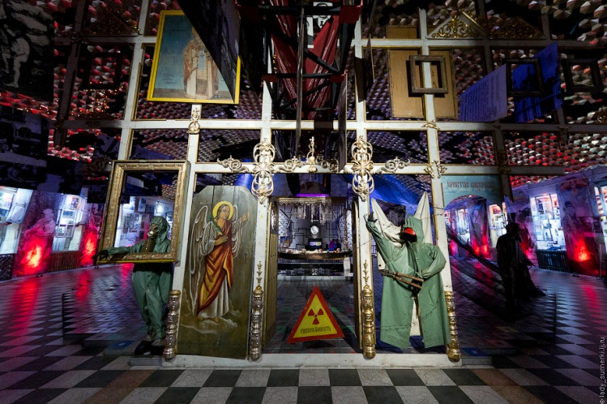
Breakfast in the hotel.
Since the morning we will go on an excursion to the National Museum "Chernobyl".
April 26th, 1986, the largest technogenic radioecological disaster of our time had occurred - a nuclear accident at the fourth power unit of the Chernobyl nuclear power plant.
The purpose of the museum's exposition is to help the mankind to comprehend the Chernobyl accident as a real factor of the possible death of our civilization, to learn the lessons of the tragedy in all spheres of life, to prevent the world from forgetting these lessons, and to become a warning to the generations of the next millennium. A lot of materials presented in the museum were published for the first time - documents, maps with the stamp " Top Secret", photographs. All these unique exhibits, including relics from the exclusion zone (old icons, folk art, local crafts representing day to day life of the inhabitants of Ukrainian Polesye), and the personal belongings of the liquidators – will make you to think about the most painful problems of the present, including environmental, social, spiritual losses , caused by a catastrophe.
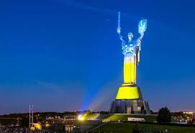
Then you will pay a visit to one of the most famous symbols of Kiev and Ukraine - the monument "Motherland" - Museum of the History of Ukraine in the Second World War.
A colossal 62-meter statue of Motherland (102 m with pedestal) is made of special stainless steel and assembled with a special crane.
The memorial complex "Museum of the History of Ukraine in World War II" occupies 10 hectares on the hill of the right bank of the Dnieper. It consists of a giant bowl of the Eternal Flame, an exhibition of military equipment from the times of World War II, as well as post-war years, the alley of the Heroic Cities.
Along the slopes of the Dnieper lays the front alley, which goes to the gallery of the Main Entrance leading to the square and the museum itself. The sculptures of the gallery embody the heroic defense of the USSR border from the German attack, the horrors of the German occupation, the guerrilla struggle, the labor feat of the rear, the battle for the Dnieper. Lunch in the city cafe.
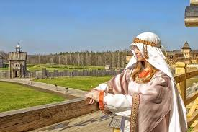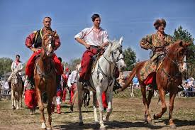
The day will not be complete if we won’t go to the park "Kievan Rus".
Ancient Kiev in Amusement Park “Kievan Rus" is the unique and inimitable place in the world, where one of the most famous and at the same time the most mysterious medieval cities of Eastern Europe - Ancient Kiev (V-XIII centuries), the capital of the great medieval state - Kievan Rus, was reconstructed. It matches the sizes of its historical center, known as Detinets of Kiev or the City of Vladimir. Its architectural image and the atmosphere of Kievan Rus was recreated fully, at a scale of 1:1, taking into account the knowledge of modern science. Dinner at the Oriental cafe or Country Complex "Partizan".
Day 3
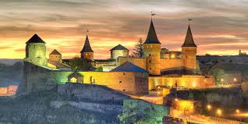
06:30 Early departure from Kiev to Kamenets-Podolsky.
14:00 Arrival at Kamyanets-Podolsky. Transfer to the hotel. Check-in at the hotel.
Sightseeing tour "Kamyanets Podolsky - historical pearl of Ukraine": deep rocky canyon, located right in the city center, Castle Bridge, Petropavlovskaya and St. Nicholas Churches, Towers Goncharnaya and Kushnirskaya, Turkish and Armenian bastions, Kamenetskaya Hall and Armenian well, Dominican and Trinitarian monasteries, Polish and Russian gates, the Peter and Paul Cathedral, Arc de Triomphe of Stanislaus Augustus, Muslim minaret, Old castle, New castle, etc. ...
Day 4
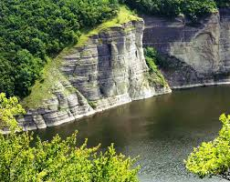
Breakfast at the hotel.
Historically-ecological excursion "Charm of Podolsky Tovtry":
Surzhinetsky canyon (mountains “upside down”) - Kitaigorod village (an amazing combination of cultures - Ukrainian, Polish, Jewish, Russian Old Believer, hypothetically - Chinese, charming landscape, ruins of the Pototsky Palace) - Soviniy Yar (natural reserve, part of the National Natural Park “Podolsky Tovtry”) - Bakota (rock monastery of XI century, springs of healing mineral water, magnificence of the Bakotian Gulf of the Dniester River), Lunch outdoors.
Optional: A boat trip along the Dniester river (Dniester Canyon - geological miracle of nature (the cost is depending on the amount of participants).
Return to the city. Overnight stay.
Day 5
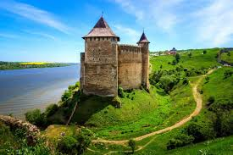
Breakfast at the hotel. Meeting with a guide in the hotel lobby.
The beginning of the excursion program: "Zhvanets - Trenches Trenches - Khotyn Fortress": Zhvanets (fortresses of the XV-XVIII centuries ) – Dniester river - the Fortress -Trenches of the St. Trinity of XVII-XVIII century (The bastion fortification of the 17th century, the conventional border of the three regions of Podillya, Galicia and Bessarabia, the point of contact of the three administrative borders of Khmelnytsky, Ternopil and Chernivtsi regions, formerly, the state border of the Russian, Austrian and Ottoman empires, between the first and second world wars - the state border of the USSR , Poland and Romania)
Transfer to Khotyn.
Excursion around Khotyn fortress.
Khotyn fortress is one of the most significant European monuments of military architecture and bastion fortification. Geopolitical issues of great importance for the Eurasian continent were repeatedly solved in the numerous battles around this fortress.
The walls of its castle, with a height of 30-40 m and a thickness of 5-6 m, the shafts of the bastions, with its deep escarp trenches, are subjects of great interest to all who visit this fortress, picturesquely towering above the Dniester.
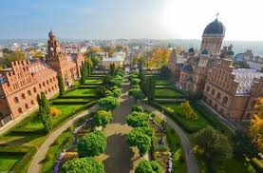
Moving to Chernivtsi.Lunch at the restaurant.
City tour around Chernivtsi – or, as it is also known, " The Little Paris of Carpathians": four main squares of the city (Central, Philharmonic, Theatrical, Cathedral), the Drama Theater. The Church of St. Nicholas (the original church with twisted domes of the beginning of the 20th century) and many other architectural and historical monuments.The tour will take you next to the main building of the Chernivtsi National University-the former residence of the metropolits of Bukovina and Dalmatia (an architectural monument of the 19th century). This unique object is included in the UNESCO World Heritage List. Walking along the pedestrian street named after O.Kobylianska (in the past Panskaya street). Return to Kamenets Podolsky. Check-in to the hotel. Overnight stay.
Day 6
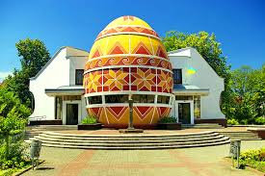
Breakfast.Departure to Kolomyia. Kolomyia is the center of Pokuttya, the city is the guard of Hutsul culture, the cradle of Western Ukrainian history, with a true architecture preserved since the reign of the Austro-Hungarian Empire. Kolomyia Museum Pysanka (painted egg, dedicated to Easter celebration) is the only museum of painted eggs in the world, the architecture and design of which can not but surprise, as the museum is built in the shape of a giant egg (the largest egg in the world). The Hutsulshchyna Museum - the collection of the museum consists of Hutsul antiques, more than 22 thousand items made of wood, processed metal and leather, yarn, embroidery.
Departure to Yaremche. Check-in at the hotel. Overnight stay.
Day 7
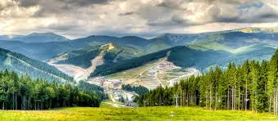
Breakfast in the hotel. 09:00 - Departure for the excursion "Pearls of Prykarpattya": Yaremche - Bukovel - Vorokhta.
En route:
Bukovel, a place, where everyone can sunbathe on the ski slopes, also, there will be a working ski lift, which will take you to the top of the mountain "Bukovel"( height 1127m above sea level). At the top of the mountain "Panorama-Bar" is situated, where everyone can try the Hutsul's mulled wine and take a picture against the backdrop of Goverla mountain.
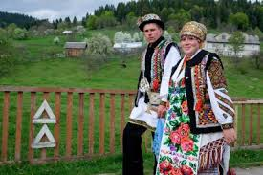
In Vorokhta: going up the mountains in the ski lift to enjoy panoramic view, visitation of the springboards, photos in Hutsul traditional clothes on horses. Vorokhta is an enchanting beauty of wild mountains, rivers ,framed in steep cliffs, and villages, scattered in the mountains.
In Yaremche: one of the most famous climatic resorts of the Carpathians is situated, right in the center of picturesque valley of the river Prut.
18:00 - departure to Mukacheve. Check in to the hotel. Overnight stay.
Day 8
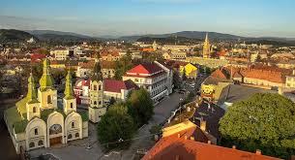
Breakfast in the hotel.
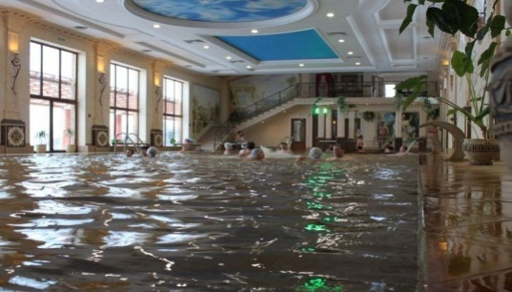
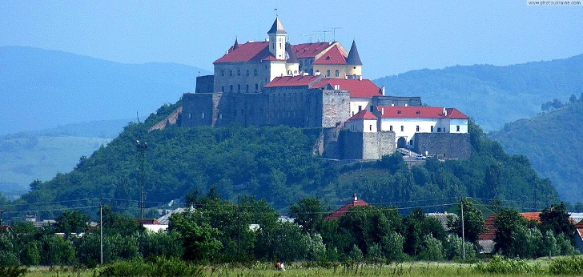
Sightseeing tour around Mukachevo - "The city over Latoritsa" with a visit to the medieval castle Palanok. The medieval architecture or restored fortification, old courtyards and galleries with exhibitions of modern sculpture will pleasantly surprise you. There are exhibits of rare items of the Stone Age, copper-bronze period, weapons and tools. A collection of items dedicated to the ethnography and day to day life of the inhabitants of the city is widely represented too , among it there are icons of the ХVI-XIX centuries. End of excursion is followed by your spare time, which you can take to have a lunch at the city.
Departure for the thermal pools of Kosino. (Entrance fee is a subject of additional payment). After bathing , transfer to Berehove. Wine tasting at the Chisai plant (subject of additional fee). Return to the hotel. Overnight stay.
Day 9
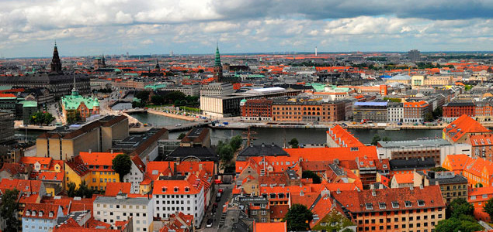
Breakfast in the hotel. Departure to Uzhhorod. City Tour.
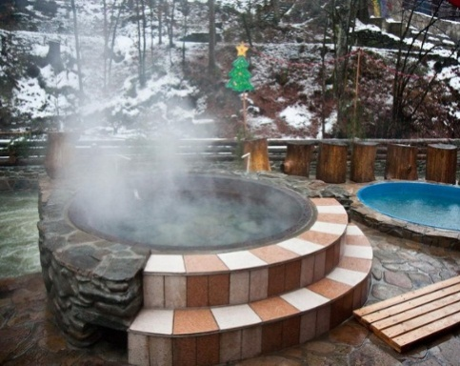
Uzhgorod is truly the "Window to Europe": it is rightfully considered one of the most important Ukrainian and European historical centers. Throughout its more than a thousand-year history, Uzhgorod has been repeatedly passed from hand to hand, changing its rulers and "masters". The architectural appearance of the city has been particularly affected by the almost six-hundred-years presence of Hungarians - many streets of Uzhgorod are very similar to the neighborhoods of the Hungarian Debrecen or Budapest: picturesque two-three stores houses, that have preserved medieval ornamentation on their walls. On the way from Uzhgorod stop in the humorous tavern-museum "Detsa at Notary". A unique tavern-museum, the concept of which is based on the vivid humor of Transcarpathian folks . The title is translated as "A shot of vodka from a notary." There will be lots of reasons to laugh: from funny signs at the entrance to the advertasings on the walls and even manu is made in funny manner with a use of the local dialect.
Transfer to the village of Lumshory, bathing in vats of mineral water (for additional fee, the amount is depending on the quantity of participants).
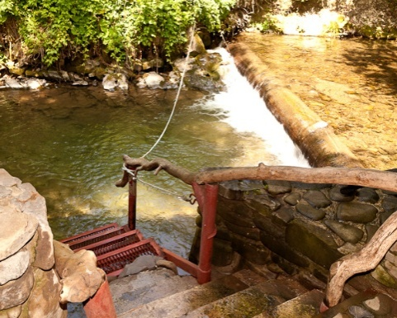
Heated water tanks, with water from a hydrogen sulfide mineral spring, started to be used for medical procedures back in the XVII century. One of the old cast iron tanks is now in Austria, and the other one is always ready for our guests !!! The tank is filled with cold mineral water, river stones are laid on the bottom, then the water is gradually heated on an open fire. When the temperature reaches 30 degrees, you can start taking a bath, alternating immersion in hot water with cooling in a cold waters of the mountain river.
Return to Mukachevo to the hotel. Overnight stay.
Day 10
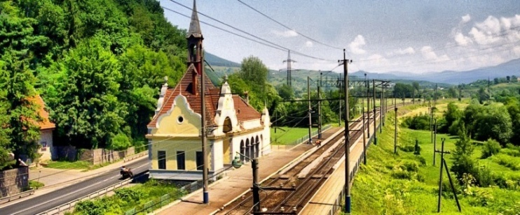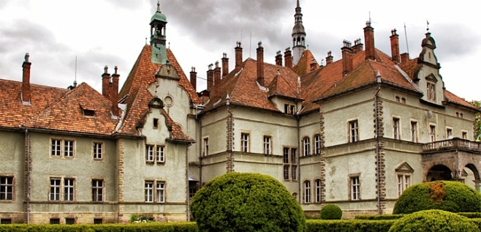
Breakfast in the hotel.
Transfer to Chynadiyevo. Stop at the station “Karpaty”. Excursion to the hunting castle of Count Schönborn. The castle of the earl of Schönborn is a true beauty of an ancient architecture and can tell lots of stories to its visitors.
12:00 Departure to Lviv. Lunch on the way.
Arrival to Lviv. Free time in the city, which you can use for visiting restaurants and cafes.
Day 11
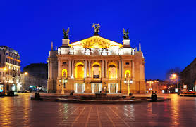
Breakfast in the hotel.
Walking tour around the city "Labyrinths of Lviv streets".
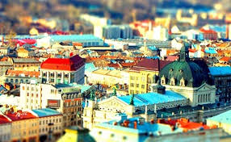
The Ensemble of the Market Square - everything here is so antique, that it seems like you moved several centuries back. Everything here feels like fairy tale and helps you to discover the real beauty of old Lviv. City Hall, Italian courtyard - a unique three-tiered Renaissance arcade-loggia, the only one in Ukraine, the main attraction of the square - the Latin Cathedral forms a magnificent duet with the Boim Chapel - the burial-vault of wealthy philistines. The Armenian cathedral and courtyard is a unique corner of the eastern architecture in Lviv. The monastic Dominican Cathedral of the Body of God is one of the largest and most outstanding examples of baroque style. The pharmacy-museum is the oldest pharmacy in Lviv. Prospekt Svobody is the main street of the city, the place where the first Lviv hotels, restaurants, cafes, banks are situated. The Opera and Ballet Theater is, of course, an architectural gem of Lviv. He is considered to be one of the most luxurious theaters in Europe. The greatness and perfection of the building is amazing. Even more delightful is the interior of the theater, which is generously decorated with colorful marble and gilding.
Free time in the city.
14:00 departure to Kiev.
21:00 later arrival in Kiev. Overnight stay.
* If necessary, there is an opportunity to book 1 night in the hotel, as well as an individual transfer.
Day 12
Breakfast. Transfer to the airport. End of service.
Cost of the program
Prices are quoted in Dollars ($) per person:
GUARANTEED TOUR (from 2 people)!

Cost of the program
Hotel | 2 | 6 | 10+1 | 15+1 | 20+1
 | $ | $ | $ | $ | $
Hotels 3 *  Raziohotel Yamskaya 3* -Kyiv  Modern Art Hotel 3* -Lviv | 1450 | 775 | 716 | 633 | 607
Hotels 4 *  BAKKARA 4* -Kyiv  Premier Hotel Dnister 4* - Lviv | 1555 | 948 | 812 | 790 | 722
Hotels 4 * +  Cosmopolite 4*+ -Kyiv  NOBILIS HOTEL 4+ - Lviv | 1861 | 1130 | 1067 | 954 | 879
Hotels 5 *  Fairmont Grand Hotel 5* -Kyiv  Astoria Hotel 5* – Lviv | 3590 | 2281 | 2208 | 1963 | 1877
*the hotels maybe be replaced by accommodation of equal category.

The price of program includes:
- 9 nights at the hotel of your choice
- Breakfasts at the hotels, 1 lunch on the way to Chernovtsy, 1 lunch outdoors.
- Transportations during the tour
- Transfers during the tour
- English speaking guide service
- Excursions with entrance fees.

The price of the program EXLUDES:
- Medical insurance
- Meals that are not mentioned in the tour description

We invite you to visit Ukraine!!

