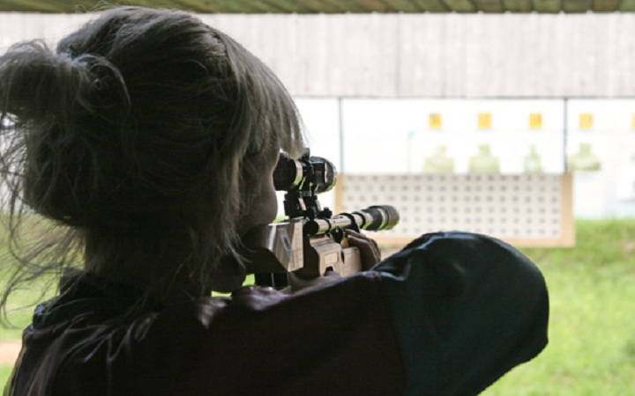

SHOOTING TOUR 1
Continuance: 1 day
Tour program
1 DAY
- ●AK-47 (10 shots)
- ●Revolver (10 shots)
- ●Vinchester (10 shots)
- ●Dragunovsniperrifle(10 shots)
- ●Glockpistol (10shots)
- ●coffe break/homemade alcohol drinks

Price from 139$ (per person)

The cost includes:
- Transfer from Kiev to shooting range-Kiev (25 km away from Kiev)
- AK-47 (10 shots)
- Revolver (10 shots)
- Vinchester (10 shots)
- Dragunovsniperrifle(10 shots)
- Glockpistol (10shots)
- coffe break/homemade alcohol drinks

