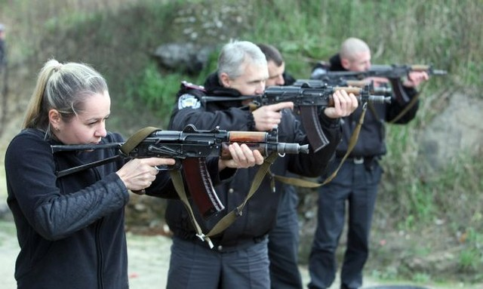

SHOOTING TOUR 3
Continuance: 1 day
Tour program
DAY 1
- ●AK-47 (20 shots)
- ●Revolver (10 shots)
- ●Vinchester (10 shots)
- ●Dragunov sniper rifle(10 shots)
- ●Glock pistol (10shots)
- ●Shooting skeet (10 shots)
- ●Shotgun (10 shots)
- ●M-16 rifle (10 shots)
- ●Gletcher TT (10 shots)
- ●coffe break/homemade alcohol drinks
Price from 239$ (per person)

The cost includes:
- Transfer from Kiev to shooting range-Kiev (25 km away from Kiev)
- AK-47 (20 shots)
- Revolver (10 shots)
- Vinchester (10 shots)
- Dragunov sniper rifle (10 shots)
- Glock pistol (10shots)
- Shooting skeet (10 shots)
- Shotgun (10 shots)
- M-16 rifle (10 shots)
- Gletcher TT (10 shots)
- coffebreak/homemade alcohol drinks

